Contents

1.Introduction 2

1. Languages of Data Science 3

2. Introduction to Python 4

3. Introduction to R Language 5

4. Introduction to SQL 7

2.Tools for Data Science 14

1. Categories of Data Science Tools 14

2. Open Source Tools for Data Science - Part 1 15

3. Open Source Tools for Data Science – Part 2 18

4. Commercial Tools for Data Science 20

5. Cloud Based Tools for Data Science 22

3. Packages. APIs, Data Sets and Models 25

1. Libraries for Data Science 25

2. Application Programming Interfaces 26

3. Data Sets- Powering Data Science 27

4. Sharing Enterprise Data – Data Asset eXchange 29

5. Machine Learning Models 30

6. The Model Asset Exchange 34

7. Explore Data sets and Models 36

# 1.Introduction

Welcome to the course!

You've begun one of the most complete overviews on data science tooling that you’ll currently find on the internet. This doesn’t mean that we cover each and every tool, but later in the course we’ll introduce a comprehensive list of tasks a data scientist needs to perform and give you the top two or three open source and commercial tools available to complete them. We also explain how the tools overlap in functionality, what their pros and cons are, and how these tools can address the whole data science pipeline.

Key Points

* Overview of data science tooling
* Tasks a data scientist need to perform
* Top open source and commercial tools used for each task
* How the tools overlap in functionality
* Pros & Cons of each tool
* How tools can address the whole data science pipeline

Let’s start with data.

Data is obviously central to data scientists.

In this course, we’ll show you how to manage, extract, transform, analyze, and visualize data. Now, you might be able to survive data science without programming skills if you use the right set of tools. However, we highly recommend getting familiar with programming and the related programming frameworks for data science.

To help you along, we’ll introduce you to the most commonly used ;

programming languages

frameworks available for data science. That said, there is a lot of automation available in the latest tooling that a data scientist can use. In this course, we’ll explain how to make use of those tools to save time and uncover inspiration.

Visual programming is available in many tools. In this course, you’ll learn how visual programming can be used to speed up development time and to help non-programmers enter the field of data science. Open source software is leading the field of data science, but its total costs of ownership, or "TCO," can be higher at times due to configuration, customization and maintenance costs.

As a result, commercial software also has its place, especially since the new generation of commercial data science software leverages open source software and open standards. This makes it easy to migrate between tools and can reduce overall TCO.

In this course, we’ll introduce you to both open source and commercial software and point out their strengths and weaknesses for data science. We'll also show you ways that you can take advantage of their respective strengths.

Finally, we'll show you how cloud computing can be used to further speed up and facilitate data scientists' work. We'll introduce you to the most commonly used and newly emerging cloud tools for data science. In addition to lectures, this course, has numerous labs to make you more familiar with the material and get hands-on experience.

There are also multiple quizzes to test your learning. Nothing more to say than we’re glad to have you in the course and happy learning. In case you have trouble in any way, please don’t hesitate to contact us in the discussion forum.

There's nothing left but to begin!

We're very happy to have you with us as you start your data science journey.  If you have any trouble with any of the course material, please don’t hesitate to contact us in the discussion forum.

Let's get started!

## Languages of Data Science

The languages of Data Science

For anyone just getting started on their data science journey, the range of technical options

Can be overwhelming. There is a dizzying amount of choice when it comes to programming languages. Each has its own strengths and weaknesses and there is no one right answer to the question of which one you should learn first. The answer to that question depends largely on your needs, the problems you are trying to solve, and who you are solving them for.

Python, R, and SQL are the languages that we recommend you consider first and foremost.

But there are so many others that have their own strengths and features.

Scala, Java, C++, and Julia are some of the most popular.

Javascript, PHP, Go, Ruby, and Visual Basic all have their own unique use cases as well.

The language you to learn will depend on;

* Things you need to accomplish and the problems you need to solve.
* What company you work for, what role you have, and the age of your existing application.

We’ll explore the answers to this question as we dive into the popular languages in the data science industry.

* There are many roles available for people who are interested in getting involved in **data science** ; Business Analyst, Database Engineer Data Analyst, Data Engineer Data Scientist, Research Scientist Software Engineer, Statistician Product Manager, Project Manager and many more.

Let’s dive into what we will learn in Lesson 1.

We will put most of our focus on the top 3 Data Science languages: Python, R, and SQL, which each have their own lessons.

Then we will go on to highlight other noteworthy languages and what makes them special. Then

we’ll finish with a short quiz to test your knowledge!

● 1.1.1 - Python ● 1.1.2 - R ● 1.1.3 - SQL ● 1.1.4 - Other Noteworthy Data Science Languages ● 1.1.5 - Practice Quiz

## Introduction to Python

In this video, we will review the high-level features of the Python programming language.

Python is a powerhouse language. It is by far the most popular programming language for data science.

According to the 2019 Kaggle Data Science and Machine Learning Survey, 75% of the over

10,000 respondents from around the world reported that they use Python on a regular basis.

Glassdoor reported that in 2019 more than 75% of data science positions listed included

Python in their job descriptions.

When asked which language an aspiring data scientist should learn first, most data scientists

say Python. You are probably thinking, why on earth is Python so popular? Well, let’s start with the people who use Python.

If you already know how to program, then Python is great for you because it uses clear, readable

syntax. You can do many of the things you are used to doing in other programming languages but with Python you can do it with less code.

If you want to learn to program, it’s also a great starter language because of the huge

global community and wealth of documentation. In fact, several different surveys in 2019 found that over 80% of data professionals worldwide use Python. Python is useful for many situations, including data science, AI and machine learning, web development, and IoT devices like the Raspberry Pi.

Large organizations that use Python heavily include IBM, Wikipedia, Google, Yahoo!, CERN,

NASA, Facebook, Amazon, Instagram, Spotify, and Reddit.

Python is a powerful general-purpose programming language that can do a lot of things.

It is widely supported by a global community and shepherded by the Python Software Foundation.

1. Python is a high-level general-purpose programming language that can be applied to many different classes of problems.

2. It has a large, standard library that provides tools suited for many different tasks, including

but not limited to databases, automation, web scraping, text processing, image processing,

machine learning, and data analytics.

3. For data science, you can use Python's scientific computing libraries such as Pandas, NumPy,

SciPy, and Matplotlib.

4. For artificial intelligence, it has TensorFlow, PyTorch, Keras, and Scikit-learn.

5. Python can also be used for Natural Language Processing (NLP) using the Natural Language

Toolkit (NLTK).

Another great selling point is the Python community, which has a well documented history

of paving the way for diversity and inclusion efforts in the tech industry as a whole. The Python language has a code of conduct executed by the Python Software Foundation that seeks to ensure safety and inclusion for all, in both online and in person python communities.

There are also communities like PyLadies that seek to create spaces for people interested

in Python to learn in safe and inclusive environments. PyLadies is an international mentorship group with a focus on helping more women become active participants and leaders in the Python open source community.

## Introduction to R Language

We will give a brief overview of the R programming language. After our last video on Python, where we discussed its wide adoption, you might be wondering why on earth you should consider learning any other language. Well, according to the results of the 2019 Kaggle Data Science survey, which had over 10k respondents from around the world, learning up to three languages can increase your salary! And R has a lot to offer you.

Like Python, R is free to use, but it's a GNU project, instead of being open source, it's actually a free software. So if Python is open source and R is free software, what’s the difference?

Well, Both open source and free software commonly refer to the same set of licenses. Many open source projects use the GNU General Public License, for example. Both open source and free software support collaboration. In many cases (but not all), these terms can be used interchangeably.

The Open Source Initiative (OSI) defines open source while the Free Software Foundation

(FSF) defines free software. Open source is more business focused, while free software is more focused on a set of values.

Back to why you should learn R. Because this is a free software project, you can use the

language in the same way that you contribute to open source, and it allows for public collaboration and private and commercial use.

Plus, R is another language supported by a wide global community of people passionate

about making it possible to use the language to solve big problems.

Who is R for?

It's most often used by statisticians, mathematicians, and data miners for developing statistical

software, graphing, and data analysis.

The language’s array-oriented syntax makes it easier to translate from math to code, especially for someone with no or minimal programming background. According to Kaggle’s Data Science and Machine Learning Survey, most folks learn R when they're a few years into their data science career, but it remains a welcoming language to those who don’t have a software programming background.

R is popular in academia but companies that use R include IBM, Google, Facebook, Microsoft,

Bank of America, Ford, TechCrunch, Uber, and Trulia.

● R has become the world’s largest repository of statistical knowledge.

● As of 2018, R has more than 15,000 publicly released packages, making it possible to conduct

complex exploratory data analysis.

● R integrates well with other computer languages, such as C++, Java, C, .Net, and

Python.

● Common mathematical operations such as matrix multiplication work straight out of

the box.

● R has stronger object-oriented programming facilities than most statistical computing

languages.

There are many ways to connect with other R users around the globe. Communities such as user!, WhyR?, SatRdays, and R-Ladies are all great to connect with. And you can also check out the R project website for R conferences and events.

## Introduction to SQL

In this video, we'll take a high-level look at SQL.

SQL is a bit different from the other languages we’ve covered so far. First off, it's formally pronounced “ess cue el,” although some people say “sequel.”

While the acronym stands for “Structured Query Language,” many people do not consider SQL to be like other software development languages because it's a non-procedural language and its scope is limited to querying and managing data.

While it is not a “data science” language per se, data scientists regularly use it because it's simple and powerful! Another couple of neat facts about SQL: it's much older than Python and R, by about 20 years, having first appeared in 1974. And, **SQL was developed at IBM**!

This language is useful in handling structured data; that is, the data incorporating relations

among entities and variables.

SQL was designed for managing data in relational databases.

Here you can see a diagram showing the general structure of a relational database.

A relational database is formed by collections of two-dimensional tables; for example, datasets

and Microsoft Excel spreadsheets. Each of these tables is then formed by a fixed number of columns and any number of rows.

BUT!

Even though SQL was originally developed for use with relational databases, because it's

so pervasive and easy to use, SQL interfaces for many NoSQL and big data repositories have

also been developed.

The SQL language is subdivided into several language elements, including clauses, expressions,

predicates, queries, and statements.

* So what makes SQL great?

Knowing SQL will help you do many different jobs in data science, including business and

data analyst, and it's a must in data engineering. When performing operations with SQL, you access the data directly.

There's no need to copy it beforehand. This can speed up workflow executions considerably.

SQL is the interpreter between you and the database.

SQL is an American National Standards Institute, or "ANSI," standard, which means if you learn SQL and use it with one database, you will be able to easily apply that SQL knowledge

to many other databases.

There are many different SQL databases available, including

MySQL, IBM Db2, PostgreSQL, Apache OpenOffice Base, SQLite, Oracle, MariaDB, Microsoft SQL Server, and more.

The syntax of the SQL you write might change a little bit based on the relational database

management system you’re using. If you are looking to learn SQL you would be best served to focus on a specific relational database and then plug into the community for that specific platform. There are also many great introductory courses on SQL available!

**Other Languages**

So far, we’ve reviewed Python, R, and SQL.

In this video, we will review some other languages that have compelling use cases for data science. Ok, so indisputably, Python, R, and SQL are the three most popular languages that data

scientists use.

But, there are many, many other languages that are worth your time when considering which language to use to solve a particular data science problem. Scala, Java, C++, and Julia are probably the most traditional data science languages on this slide.

But JavaScript, PHP, Go, Ruby, Visual Basic, and others have all found their place in the

data science community as well!

**Java**

I won’t dive as deeply into each of these languages, but I'll mention some notable highlights.

**Java** is a tried-and-true general-purpose object oriented programming language.

It's been widely adopted in the enterprise space and is designed to be fast and scalable.

**Java** applications are compiled to bytecode and run on the Java Virtual Machine, or "JVM."

Some notable **data science tools** built with Java include ;

1. Weka, for data mining
2. Java-ML, which is a machine learning library
3. Apache MLlib, which makes machine learning scalable
4. Deeplearning4j, for deep learning.

Apache Hadoop is another Java-built application.

It manages data processing and storage for big data applications running in clustered

systems.

**Scala**

This is a general-purpose programming language that provides support for functional programming and a strong static type system.

Many of the design decisions in the construction of the Scala language were made to address

criticisms of Java. Scala is also interoperable with Java, as it runs on the JVM.

The name "Scala" is a combination of "scalable" and "language."

This language is designed to grow along with the demands of its users. For data science, the most popular program built using Scala is Apache Spark. Spark is a fast and general-purpose cluster computing system. It provides APIs that make parallel jobs easy to write, and an optimized engine that supports general computation graphs. Spark includes Shark, which is a query engine; MLlib, for machine learning; GraphX, for graph processing; and Spark Streaming.

Apache Spark was designed to be faster than Hadoop.

**C++**

A general-purpose programming language. It is an extension of the C programming language, or "C with Classes.” C++ improves processing speed, enables system programming, and provides broader control over the software application.

Many organizations that use Python or other high-level languages for data analysis and exploratory tasks still rely on C++ to develop programs that feed that data to customers

in real-time. For data science, a popular deep learning library for dataflow called TensorFlow was built with C++. But while C++ is the foundation of TensorFlow, it runs on a Python interface, so you don’t need to know C++ to use it.

MongoDB, a NoSQL database for big data management, was built with C++.

Caffe is a deep learning algorithm repository built with C++, with Python and MATLAB bindings.

A core technology for the World Wide Web, JavaScript is a general-purpose language that

extended beyond the browser with the creation of Node.js and other server-side approaches.

Javascript is NOT related to the Java language.

For data science, the most popular implementation is undoubtedly TensorFlow.js.

TensorFlow.js makes machine learning and deep learning possible in Node.js as well as in

the browser. TensorFlow.js was also adopted by other open source libraries, including brain.js and machinelearn.js.

The R-js project is another great implementation of JavaScript for data science. R-js has re-written linear algebra specifications from the R Language into Typescript. This re-write will provide a foundation for other projects to implement more powerful math base frameworks like Numpy and SciPy of Python.

Typescript is a superset of JavaScript.

**Julia** w

Was designed at MIT for high-performance numerical analysis and computational science.

It provides speedy development like Python or R, while producing programs that run as fast as C or Fortran programs.

Julia is compiled, which means that the code is executed directly on the processor as executable code; it calls C, Go, Java, MATLAB, R, Fortran, and Python libraries; and has refined parallelism.

The Julia language is relatively new, having been written in 2012, but it has a lot of promise for future impact on the data science industry. JuliaDB is a particularly useful application of Julia for data science. It's a package for working with large persistent data sets. That's as far as we’ll dig into the many languages that are used to solve data science problems. If you have experience with a particular language, I recommend you do a web search to see what might already be possible in terms of using it for data science. You might be surprised at the possibilities!

**Practice Quiz - Languages**

**TOTAL POINTS 6**

1.

Question 1

Which of the following statements is true?

**1 / 1 point**



Python is the most popular language in data science.



80% of data scientists worldwide use Python.



Python is useful for AI, machine learning, web development, and IoT.



Keras, Scikit-learn, Matplotlib, Pandas, and TensorFlow are all Python libraries



All of the above

**Correct**

2.

Question 2

Which of the following are SQL databases? (Select all that apply.)

**1 / 1 point**



MySQL

**Correct**



Oracle

**Correct**



MariaDB

**Correct**



MongoDB



PostgreSQL

**Correct**



CouchDB

3.

Question 3

Which statements are true about Open Source and Free Software? (Select all that apply.)

**0 / 1 point**



Free Software and Open Source can be used interchangeably.

**This should not be selected**



Free Software can always be run, studied, modified and redistributed with or without changes.



Most of Free Software licenses also qualify for Open Source.



Open Source Software can be modified without sharing the modified source code depending on the Open Source license.

**Correct**

4.

Question 4

Is the following statement true or false: R integrates well with other computer languages like C++, Java, C, .Net and Python.

**1 / 1 point**



True



False

**Correct**

5.

Question 5

Which of the following languages can be used for data science?

**1 / 1 point**



R



Julia



Java



Javascript



Scala



SQL



All of the above

**Correct**

6.

Question 6

Which of the following is used to make Artificial Intelligence and Machine Learning possible? (Select all that apply.)

**0 / 1 point**



Oracle



PyTorch



TensorFlow.js

**Correct**



Apache Spark

**Correct**



GNU



Caffe

You didn’t select all the correct answers

# 2.Tools for Data Science

## Categories of Data Science Tools

**Open source tools** are available for various data science tasks.

In subsequent videos we’ll walk through the most commonly used open source tools for

those tasks. The most important tools are covered throughout this course.

1. Data Management - the process of persisting and retrieving data.
2. Data Integration and Transformation, often referred to as Extract, Transform, and Load, or “ETL,” is the process of retrieving data from remote data management systems.

Transforming data and loading it into a local data management system is also part of Data

Integration and Transformation.

1. Data Visualization is part of an initial data exploration process, as well as being part

of a final deliverable.

1. Model Building is the process of creating a machine learning or deep learning model

using an appropriate algorithm with a lot of data.

1. Model deployment makes such a machine learning or deep learning model available to third-party applications.

1. Model monitoring and assessment ensures continuous performance quality checks on the deployed models.

These checks are for accuracy, fairness, and adversarial robustness.

1. Code asset management uses versioning and other collaborative features to facilitate

Teamwork.

1. Data asset management brings the same versioning and collaborative components to data. Data asset management also supports replication, backup, and access right management. Development environments, commonly known as Integrated Development Environments, or “IDEs”, are tools that help the data scientist to implement, execute, test, and deploy their work.

1. Execution environments are tools where data preprocessing, model training, and deployment take place.
2. Finally, there is fully integrated, visual tooling available that covers all the previous

tooling components, either partially or completely.

## Open Source Tools for Data Science - Part 1

In part one of this two-part series, we’ll cover data management, open source data integration,

transformation, and visualization tools.

The most widely used open source **data management tools** are relational databases such as

MySQL and PostgreSQL.

NoSQL databases such as MongoDB Apache CouchDB, and Apache Cassandra; and file-based tools such as the Hadoop File System or Cloud File systems like Ceph.

Finally, Elastic search is mainly used for storing text data and creating a search index for

fast document retrieval.

The task of data integration and transformation in the classic data warehousing world is called

ETL, which stands for “extract, transform, and load.”

These days, data scientists often propose the term “ELT” – Extract, Load, Transform “ELT”,

stressing the fact that data is dumped somewhere and the data engineer or data scientist themself

is responsible for data.

Another term for this process has now emerged: “data refinery and cleansing.”

**Here are the most widely used open source data integration and transformation tools:**

Apache AirFlow, originally created by AirBNB;

KubeFlow, which enables you to execute data science pipelines on top of Kubernetes;

Apache Kafka, which originated from LinkedIn;

Apache Nifi, which delivers a very nice visual editor;

Apache SparkSQL (which enables you to use ANSI SQL and scales up to compute clusters

of 1000s of nodes)

NodeRED, which also provides a visual editor. NodeRED consumes so little in resources that it even runs on small devices like a Raspberry Pi.

**We’ll now introduce the most widely used open source data visualization tools.**

We have to distinguish between programming libraries where you need to use code and tools

that contain a user interface. The most popular libraries are covered in the next videos.

A similar approach uses Hue, which can create visualizations from SQL queries.

Kibana, a data exploration and visualization web application, is limited to Elasticsearch

(the data provider).

Finally, Apache Superset is a data exploration and visualization web application.

Model deployment is extremely important.

Once you’ve created a machine learning model capable of predicting some key aspects of

the future, you should make that model consumable by other developers and turn it into an API.

Apache Prediction IO currently only supports Apache Spark ML models for deployment, but

support for all sorts of other libraries is on the roadmap.

Seldon is an interesting product since it supports nearly every framework, including TensorFlow, Apache SparkML, R, and scikit-learn. Seldon can run on top of Kubernetes and Redhat OpenShift.

Another way to deploy SparkML models is by using MLeap.

Finally, TensorFlow can serve any of its models using the TensorFlow service.

You can deploy to an embedded device like a Raspberry Pi or a smartphone using TensorFlow

Lite, and even deploy to a web browser using TensorFlow dot JS.

**Model monitoring is another crucial step.**

Once you’ve deployed a machine learning model, you need to keep track of its prediction

performance as new data arrives in order to maintain outdated models.

Following are some examples of model monitoring tools:

Model DB is a machine model meta database where information about the models are stored and

can be queried.

It natively supports Apache Spark ML Pipelines and scikit-learn.

A generic, multi-purpose tool called Prometheus is also widely used for machine learning model

monitoring, although it’s not specifically made for this purpose.

Model performance is not exclusively measured through accuracy.

Model bias against protected groups like gender or race is also important. The IBM AI Fairness 360 open source toolkit does exactly this. It detects and mitigates against bias in machine learning models.

Machine learning models, especially neural-network-based deep learning models, can be subject to adversarial attacks, where an attacker tries to fool the model with manipulated data or by manipulating the model itself. The IBM Adversarial Robustness 360 Toolbox can be used to detect vulnerability to adversarial attacks and help make the model more robust.

Machine learning modes are often considered to be a black box that applies some mysterious

“magic.” The IBM AI Explainability 360 Toolkit makes the machine learning process more understandable by finding similar examples within a dataset that can be presented to a user for manual comparison.

The IBM AI Explainability 360 Toolkit can also illustrate training for a simpler machine

learning model by explaining how different input variables affect the final decision

of the model.

**Options for code asset management tools have been greatly simplified**:

For code asset management – also referred to as version management or version control

– **Git** is now the standard. Multiple services have emerged to support Git, with the most prominent being GitHub, which provides hosting for software development version management.

The runner-up is definitely **GitLab**, which has the advantage of being a fully open source

platform that you can host and manage yourself. Another choice is Bitbucket.

Data asset management, also known as data governance or data lineage, is another crucial

part of enterprise grade data science. Data has to be versioned and annotated with metadata.

**Apache Atlas** is a tool that supports this task.

Another interesting project, **ODPi Egeria**, is managed through the Linux Foundation and

is an open ecosystem. It offers a set of open APIs, types, and interchange protocols that metadata repositories use to share and exchange data.

Finally, Kylo is an open source data lake management software platform that provides

extensive support for a wide range of data asset management tasks. This concludes part one of this two-part series. Now let’s move on to part two.

## Open Source Tools for Data Science – Part 2

Welcome to part two of this series.

In this section, we’ll cover the development environment, open source data integration,

transformation, and visualization tools.

One of the most popular current development environments that data scientists are using

is “Jupyter.”

Jupyter first emerged as a tool for interactive Python programming; it now supports more than

a hundred different programming languages through “kernels.”

Kernels shouldn’t be confused with operating system kernels.

Jupyter kernels are encapsulating the different interactive interpreters for the different

programming languages.

A key property of Jupyter Notebooks is the ability to unify documentation, code, output

from the code, shell commands, and visualizations into a single document.

JupyterLab is the next generation of Jupyter Notebooks and in the long term, will actually

replace Jupyter Notebooks.

The architectural changes being introduced in JupyterLab makes Jupyter more modern and

modular.

From a user’s perspective, the main difference introduced by JupyterLab is the ability to

open different types of files, including Jupyter Notebooks, data, and terminals.

You can then arrange these files on the canvas. Although Apache Zeppelin has been fully reimplemented, it’s inspired by Jupyter Notebooks and provides a similar experience.

One key differentiator is the integrated plotting capability.

In Jupyter Notebooks, you are required to use external libraries in Apache Zeppelin,

and plotting doesn’t require coding.

You can also extend these capabilities by using additional libraries. RStudio is one of the oldest development environments for statistics and data science, having been introduced in 2011.

It exclusively runs R and all associated R libraries. However, Python development is possible and R is therefore tightly integrated into this tool to provide an optimal user experience.

RStudio unifies programming, execution, debugging, remote data access, data exploration, and

visualization into a single tool.

Spyder tries to mimic the behaviour of RStudio to bring its functionality to the Python world.

Although Spyder does not have the same level of functionality as RStudio, data scientists

do consider it an alternative. But in the Python world, Jupyter is used more frequently.

This diagram shows how Spyder integrates code, documentation, visualizations, and other components into a single canvas.

Sometimes your data doesn’t fit into a single computer’s storage or main memory capacity.

That’s where cluster execution environments come in.

The well-known cluster-computing framework Apache Spark is among the most active Apache

projects and is used across all industries, including in many Fortune 500 companies.

The key property of Apache Spark is linear scalability.

This means, if you double the number of servers in a cluster, you’ll also roughly double

its performance.

After Apache Spark began to gain market share, Apache Flink was created.

The key difference between Apache Spark and Apache Flink is that Apache Spark is a batch

data processing engine, capable of processing huge amounts of data file by file.

Apache Flink, on the other hand, is a stream processing image, with its main focus on processing real-time data streams.

Although engine supports both data processing paradigms, Apache Spark is usually the choice

in most use cases.

One of the latest developments in the data science execution environments is called “Ray,”

which has a clear focus on large-scale deep learning model training.

**Let’s look at open source tools for data scientists that are fully integrated and visual**.

With these tools, no programming knowledge is necessary. Most important tasks are supported by these tools; these tasks include data integration, transformation, data visualization, and model building.

KNIME originated at the University of Konstanz in 2004. As you can see, KNIME has a visual user interface with drag-and-drop capabilities. It also has built-in visualization capabilities.

Knime can be be extended by programming in R and Python, and has connectors to Apache

Spark.

Another example of this group of tools is Orange. It’s less flexible than KNIME, but easier to use. In this video, you’ve learned about the most common data science tasks and which open

source tools are relevant to those tasks. In the next video, we’ll describe some established commercial tools that you’ll encounter in your data science experience.

## Commercial Tools for Data Science

We previously covered open source tools for data science.

Now, let’s look at the commercial options you’ll find in many enterprise projects. Let’s revisit our overview of different tool categories.

In data management, most of an enterprise’s relevant data is stored in an Oracle Database, Microsoft SQL Server, or IBM Db2. Although open source databases are gaining popularity, those three data management products are still considered the industry-standard. They won’t disappear in the near future.

It’s not just about functionality. Data is at the heart of every organization, and the availability of commercial supports plays a major role.

Commercial supports are delivered directly from software vendors, influential partners,

and support networks. When we focus on commercial data integration tools, we’re talking about “extract, transform, and load,” or “ETL” tools.

According to a Gartner Magic Quadrant, Informatica Powercenter and IBM InfoSphere DataStage are the leaders, followed by products from SAP, Oracle, SAS, Talend, and Microsoft.

These tools support design and deployment of ETL data-processing pipelines through a

graphical interface.

They also provide connectors to most of the commercial and open source target information

systems.

Finally, Watson Studio Desktop includes a component called Data Refinery, which enables

the defining and execution of data integration processes in a spreadsheet style.

In the commercial environment, data visualizations are utilizing business intelligence, or “BI”,

tools. Their main focus is to create visually attractive and easy-to-understand reports and live dashboards.

The most prominent commercial examples are: Tableau, Microsoft Power BI, and IBM Cognos

Analytics. Another type of visualization targets data scientists rather than regular users.

A sample problem might be “How can different columns in a table relate to each other?”

This type of functionality is contained in Watson Studio Desktop.

If you want to build a machine learning model using a commercial tool, you should consider

using a data mining product.

The most prominent of these types of products are: SPSS Modeler and SAS Enterprise Miner.

In addition, A version of SPSS Modeler is also available in Watson Studio Desktop, based

on the cloud version of the tool.

We’ll talk more about cloud-based tools in the next video.

In commercial software, model deployment is tightly integrated in the model building process.

This diagram shows an example of the SPSS Collaboration and Deployment Services which

are used to deploy any type of asset created by the SPSS software tools suite.

Other vendors use the same type of process.

Commercial software can also export models in an open format.

For example, SPSS Modeler supports the exporting of models as Predictive Model Markup Language,

or PMML, which can be read by many other commercial and open software packages.

Model monitoring is a new discipline and there are currently no relevant commercial tools

available.

As a result, open source is the first choice.

The same is true for code asset management.

Open source with Git and GitHub is the effective standard.

Data asset management, often called data governance or data lineage, is a crucial part of enterprise

grade data science.

Data must be versioned and annotated using metadata.

Vendors, including Informatica Enterprise Data Governance and IBM, provide tools for

these specific tasks.

The IBM InfoSphere Information Governance Catalog covers functions like data dictionary,

which facilitates discovery of data assets.

Each data asset is assigned to a data steward -- the data owner.

The data owner is responsible for that data asset and can be contacted.

Data lineage is also covered; this enables a user to track back through the transformation

steps followed in creating the data assets.

The data lineage also includes a reference to the actual source data.

Rules and policies can be added to reflect complex regulatory and business requirements

for data privacy and retention.

Watson Studio is a fully integrated development environment for data scientists.

It’s usually consumed through the cloud, and we’ll cover more about it in a later

lesson.

There is also a desktop version available.

Watson Studio Desktop combines Jupyter Notebooks with graphical tools to maximize data scientists’

performance.

Watson Studio, together with Watson Open Scale, is a fully integrated tool covering the full

data science life cycle and all the tasks we’ve discussed previously.

We’ll talk more about both in the next lesson.

but just keep in mind that they can be deployed in a local data center on top of Kubernetes

or RedHat OpenShift.

Another example of a fully integrated commercial tool is H2O Driverless AI, which covers the

complete data science life cycle.

In this lesson, you’ve learned how most common data science tasks are supported by

commercial tools.

In the next video, we’ll discover data science tools that are available exclusively on the

cloud.

## Cloud Based Tools for Data Science

Since we’ve previously covered open source tools for data science, let’s look at the

commercial options you’ll find in many enterprise projects.

Take another look at the overview of different tool categories.

Since cloud products are a newer species, they follow the trend of having multiple tasks

integrated in tools.

This especially holds true for the tasks marked green in the diagram.

Let’s start with the fully integrated visual tools category.

Since these tools introduce a component where large scale execution of data science workflows

happens in compute clusters, we’ve changed the title here and added the word “Platform.”

These clusters are composed of multiple server machines, transparently for the user, in the

background.

Watson Studio, together with Watson OpenScale, covers the complete development life cycle

for all data science, machine learning, and AI tasks.

Another example is Microsoft Azure Machine Learning.

This is also a fully cloud-hosted offering supporting the complete development life cycle

of all data science, machine learning, and AI tasks.

And finally, another example is H2O Driverless AI, which we’ve already introduced in the

last video.

Although it is a product that you download and install, one-click deployment is available

for the common cloud service providers.

Since operations and maintenance are not done by the cloud provider, as is the case with

Watson Studio, Open Scale, and Azure Machine Learning, this delivery model should not be

confused with Platform or Software as a Service -- PaaS or SaaS.

In data management, with some exceptions, there are SaaS versions of existing open source

and commercial tools.

Remember, SaaS stands for “software as a service.”

It means that the cloud provider operates the tool for you in the cloud.

As an example, the cloud provider operates the product by backing up your data and configuration

and installing updates.

As mentioned, there is proprietary tooling, which is only available as a cloud product.

Sometimes it’s only available from a single cloud provider.

One example of such a service is Amazon Web Services DynamoDB, a NoSQL database that allows

storage and retrieval of data in a key-value or a document store format.

The most prominent document data structure is JSON (pronounced “jay-sun”).

Another flavour of such a service is Cloudant, which is a database-as-a-service offering.

But, under the hood it is based on the open source Apache CouchDB.

It has an advantage: although complex operational tasks like updating, backup, restore, and

scaling are done by the cloud provider, under the hood this offering is compatible with

CouchDB.

Therefore, the application can be migrated to another CouchDB server without changing

the application.

And IBM offers Db2 as a service as well.

This is an example of a commercial database made available as a software-as-a-service

offering in the cloud, taking operational tasks away from the user.

When it comes to commercial data integration tools, we talk not only about “extract,

transform, and load,” or “ETL” tools, but also about “extract, load, and transform,”

or “ELT,” tools.

This means the transformation steps are not done by a data integration team but are pushed

towards the domain of the data scientist or data engineer.

Two widely used commercial data integration tools are Informatica Cloud Data Integration

and IBM’s Data Refinery.

Data Refinery enables transformation of large amounts of raw data into consumable, quality

information in a spreadsheet-like user interface.

Data Refinery is part of IBM Watson Studio.

The market for cloud data visualization tools is huge, and every major cloud vendor has

one.

An example of a smaller company’s cloud-based data visualization tool is DataMeer.

IBM offers it’s famous Cognos Business intelligence suite as cloud solution as well.

IBM Data Refinery also offers data exploration and visualization functionality in Watson

Studio.

Again, these are just some examples of a rapidly changing and growing commercial ecosystem

among a huge number of established and emerging vendors.

In Watson Studio, an abundance of different visualizations can be used to better understand

data.

For example, this 3D bar chart enables you to visualize a target value on the vertical

dimension, which is dependent on two other values on the horizontal dimensions.

Coloring enables you to visualize a third dimension.

Hierarchical edge bundling enables you to visualize correlations and affiliations between

entities.

If sufficient, a classic bar chart can do the job as well, whereas a 2D scatter plot

with a heat map shows two dependent data fields, one on the y axis and one as color intensity.

A tree map shows distribution of subsets within a set, the famous pie chart does the same

but in a non-hierarchical manner, and finally, a word cloud pops out significant terms in

a document corpus.

Model building can be done using a service such as Watson Machine Learning.

Watson Machine Learning can train and build models using various open source libraries.

Google has a similar service on their cloud called AI Platform Training.

Nearly every cloud provider has a solution for this task.

Model deployment in commercial software is usually tightly integrated to the model building

process.

Here is an example of the SPSS Collaboration and Deployment Services, which can be used

to deploy any type of asset created by the SPSS software tools suite.

The same holds for other vendors.

In addition, commercial software can export models in an open format.

As an example, SPSS Modeler supports exporting models as Predictive Model Markup Language,

or “PMML,” which can be read by numerous other commercial and open software packages.

Watson Machine Learning can also be used to deploy a model and make it available to consumers

using a REST interface.

Amazon SageMaker Model Monitor is an example of a cloud tool that continuously monitors

deployed machine learning and deep learning models.

Again, every major cloud provider has similar tooling.

This is also the case for Watson OpenScale.

OpenScale and Watson Studio…

…unify the landscape.

Everything marked in green can be done using Watson Studio and Watson OpenScale.

We’ll cover Open Scale will be covered in a later video.

You’ve learned how the most common tasks in data science are supported by commercial

cloud tools.

Integration provides us the ability to use the same tools for multiple tasks.

In the next videos, we’ll look at packages, APIs, datasets, and models for data science.

# 3. Packages. APIs, Data Sets and Models

## Libraries for Data Science

In this video, we will review several data science libraries.

**Libraries** are a collection of functions and methods that enable you to perform a wide

variety of actions without writing the code yourself.

We will focus on Python libraries: Scientific Computing Libraries in Python Visualization Libraries in Python High-Level Machine Learning and Deep Learning Libraries – “High-level” simply means you don’t have to worry about details, although this makes it difficult to study or improve Deep Learning Libraries in Python Libraries used in other languages

Libraries usually contain built-in modules providing different functionalities that you

can use directly; these are sometimes called “frameworks.” There are also extensive libraries, offering a broad range of facilities.

**Pandas** offers data structures and tools for effective data cleaning, manipulation, and analysis.

It provides tools to work with different types of data. The primary instrument of Pandas is a two-dimensional table consisting of columns and rows. This table is called a “**DataFrame**” and is designed to provide easy indexing so you can work with your data.

**NumPy** libraries are based on arrays, enabling you to apply mathematical functions to these

arrays. Pandas is actually built on top of NumPy. Data visualization methods are a great way to communicate with others and show the meaningful results of analysis. These libraries enable you to create graphs, charts and maps.

The **Matplotlib** package is the most well-known library for data visualization, and it’s

excellent for making graphs and plots. The graphs are also highly customizable.

Another high-level visualization library, Seaborn, is based on matplotlib.

**Seaborn** makes it easy to generate plots like heat maps, time series, and violin plots.

For machine learning,

The **Scikit**-learn library contains tools for statistical modeling, including regression, classification, clustering and others. It is built on NumPy, SciPy, and matplotlib, and it’s relatively simple to get started. For this high-level approach, you define the model and specify the parameter types you would like to use.

For deep learning, **Keras** enables you to build the standard deep learning model. Like Scikit-learn, the high-level interface enables you to build models quickly and simply. It can function using graphics processing units (GPU), but for many deep learning cases a lower-level environment is required.

**TensorFlow** is a low-level framework used in large scale production of deep learning models.

It’s designed for production but can be unwieldy for experimentation.

**Pytorch** is used for experimentation, making it simple for researchers to test their ideas

**Apache Spark** is a general-purpose cluster-computing framework that enables you to process data using compute clusters. This means that you process data in parallel, using multiple computers simultaneously.

The **Spark** library has similar functionality as Pandas Numpy Scikit-learn Apache Spark data processing jobs can use Python R Scala, or SQL. There are many libraries for Scala, which is predominately used in data engineering but is also sometimes used in data science.

Let’s discuss some of the libraries that are complementary to Spark Vegas is a Scala library for statistical data visualizations. With Vegas, you can work with data files as well as Spark DataFrames. For deep learning, you can use BigDL. R has built-in functionality for machine learning and data visualization, but there are also several complementary libraries: ggplot2 is a popular library for data visualization in R. You can also use libraries that enable you to interface with Keras and TensorFlow. R has been the de-facto standard for open source data science but it is now being superseded by Python.

## Application Programming Interfaces

In this video we will discuss Application Programming Interfaces, or APIs. Specifically,

we will discuss: What an API is, API Libraries, REST APIs, including:

Request and Response. An API lets two pieces of software talk to each other. For example

you have your program, you have some data, you have other software components. You use

the API to communicate with the other software components.You don’t have to know how the

API works, you just need to know its inputs and outputs. Remember, the API only refers

to the interface, or the part of the library that you see. The “library” refers to

the whole thing. Consider the pandas library. Pandas is actually a set of software components,

many of which are not even written in Python. You have some data.

You have a set of software components. We use the pandas API to process the data

by communicating with the other software components. There can be a single software component at

the back end, but there can be a separate API for different languages. Consider TensorFlow,

written in C++. There are separate APIs in Python, JavaScript,

C++ Java, and Go. The API is simply the interface.

There are also multiple volunteer-developed APIs for TensorFlow; for example Julia, MATLAB,

R, Scala, and many more. REST APIs are another popular type of API. They enable you to communicate

using the internet, taking advantage of storage, greater data

access, artificial intelligence algorithms, and many other resources. The RE stands for

“Representational,” the S stands for “State,” the T stand for “Transfer.” In rest APIs,

your program is called the “client.” The API communicates with a web service that you

call through the internet. A set of rules governs Communication, Input or Request, and

Output or Response. Here are some common API-related terms. You or your code can be thought of

as a client. The web service is referred to as a resource. The client finds the service

through an endpoint. The client sends the request to the resource and the response to

the client. HTTP methods are a way of transmitting data over the internet We tell the REST APIs

what to do by sending a request. The request is usually communicated through an HTTP message.

The HTTP message usually contains a JSON file, which contains instructions for the operation

that we would like the service to perform. This operation is transmitted to the web service

over the internet. The service performs the operation. Similarly, the web service returns

a response through an HTTP message, where the information is usually returned using

a JSON file. This information is transmitted back to the

client. The Watson Speech to Text API is an example

of a REST API. This API converts speech to text. In the API call, you send a copy of

the audio file to the API; this process is called a post request. The API then sends

the text transcription of what the individual is saying. The API is making a get request.

The Watson Language-Translator API provides another example. You send the text you would

like to translate into the API, the API translates the text and sends the translation back to

you. In this case we translate English to Spanish. In this video, we’ve discussed

what an API is, API Libraries, REST APIs, including Request and Response. Thank you

for watching this video.

## Data Sets- Powering Data Science

In this video we’ll discuss data sets: what they are, why they are important in data science,

and where to find them.

Let’s first loosely define what a data set is.

A data set is a structured collection of data.

Data embodies information that might be represented as text, numbers, or media such as images,

audio, or video files.

A data set that is structured as tabular data comprises a collection of rows, which in turn

comprise columns that store the information.

One popular tabular data format is "comma separated values," or CSV.

A CSV file is a delimited text file where each line represents a row and data values

are separated by a comma.

For example, imagine a data set of observations from a weather station.

Each row represents an observation at a given time, while each column contains information

about that particular observation, such as the temperature, humidity, and other weather

conditions.

Hierarchical or network data structures are typically used to represent relationships

between data.

Hierarchical data is organized in a tree-like structure, whereas network data might be stored

as a graph.

For example, the connections between people on a social networking website are often represented

in the form of a graph.

A data set might also include raw data files, such as images or audio.

The MNIST dataset is popular for data science.

It contains images of handwritten digits and is commonly used to train image processing

systems.

Traditionally, most data sets were considered to be private because they contain proprietary

or confidential information such as customer data, pricing data, or other commercially

sensitive information.

These data sets are typically not shared publicly.

Over time, more and more public and private entities such as scientific institutions,

governments, organizations and even companies have started to make data sets available to

the public as “open data," providing a wealth of information for free.

For example, the United Nations and federal and municipal governments around the world

have published many data sets on their websites, covering the economy, society, healthcare,

transportation, environment, and much more.

Access to these and other open data sets enable data scientists, researchers, analysts, and

others to uncover previously unknown and potentially useful insights.

They can create new applications for both commercial purposes and the public good.

They can also carry out new research.

Open data has played a significant role in the growth of data science, machine learning,

and artificial intelligence and has provided a way for practitioners to hone their skills

on a wide variety of data sets.

There are many open data sources on the internet.

You can find a comprehensive list of open data portals from around the world on the

Open Knowledge Foundation’s datacatalogs.org website.

The United Nations, the European Union, and many other governmental and intergovernmental

organizations maintain data repositories providing access to a wide range of information.

On Kaggle, which is a popular data science online community, you can find and contribute

data sets that might be of general interest.

Last but not least, Google provides a search engine for data sets that might help you find

the ones that have particular value for you.

It’s important to recognize that open data distribution and use might be restricted,

as defined by its licensing terms.

In absence of a license for open data distribution, many data sets were shared in the past under

open source software licenses.

These licenses were not designed to cover the specific considerations related to the

distribution and use of data sets.

To address the issue, the Linux Foundation created the Community Data License Agreement,

or CDLA.

Two licenses were initially created for sharing data: CDLA-Sharing and CDLA-Permissive.

The CDLA-Sharing license grants you permission to use and modify the data.

The license stipulates that if you publish your modified version of the data you must

do so under the same license terms as the original data.

The CDLA-Permissive license also grants you permission to use and modify the data.

However, you are not required to share changes to the data.

Note that neither license imposes any restrictions on results you might derive by using the data,

which is important in data science.

Let’s say, for example, that you are building a model that performs a prediction.

If you are training the model using CDLA-licensed data sets, you are under no obligation to

share the model, or to share it under a specific license if you do choose to share it.

In this video you’ve learned about open data sets, their role in data science, and

where to find them.

We’ve also introduced the Community Data License Agreement, which makes it easier to

share open data.

One important aspect that we didn’t cover in this video is data quality and accuracy,

which might vary greatly depending on who collected and contributed the data set.

While some open data sets might be good enough for personal use, they might not meet enterprise

requirements due to the impact they might have on the business.

In the next module, you will learn about the Data Asset eXchange, a curated open data repository.

## Sharing Enterprise Data – Data Asset eXchange

Despite the growth of open data sets that are available to the public, it can still

be difficult to discover data sets that are both high quality and have clearly defined

license and usage terms.

To help solve this challenge, IBM created the Data Asset eXchange, or "DAX,”, which

we’ll introduce in this video.

DAX provides a trusted source for finding open data sets that are ready for to use in

enterprise applications.

These data sets and which cover a wide variety of domains, including images, video, text,

and audio.

Because DAX provides a high level of curation for data set quality, as well as licensing

and usage terms, DAX data sets are typically easier to adopt, whether in research or commercial

projects.

Wherever possible, DAX aims to make data sets available under one of the variants of the

CDLACommunity Data License Agreement, in order to foster data sharing and collaboration.

DAX also provides a single place to access unique data sets, in particular from IBM Research

projects.

To make it easier for developers to get started with using the data sets, DAX also provides

tutorials in the form of notebooks that walk through the basics of data cleaning, pre-processing,

and exploratory analysis.

For some data sets, there are also notebooks illustrating how to perform more complex analysis,

such as creating charts, statistical analysis, time-series analysis, training machine learning

models, and integrating deep learning via using the Model Asset eXchange, (a project

closely related to DAX and also available on the IBM Developer website).

In this way, DAX helps developers to create end-to-end analytic and machine learning workflows

and to consume open data and models with confidence under clearly defined license terms.

Let’s say you’ve found a data set that might be of interest to you.

On the data set page you can download the compressed data set archive from cloud storage,

explore the data set using Jupyter Notebooks, review the data set metadata, such as format,

licensing terms and size, and preview some parts of the data set.

Most data sets on DAX are complemented by one or more Jupyter Notebooks that you can

use to perform data cleaning, pre-processing, and exploratory analysis.

These notebooks run "as is"as is in Watson Studio, IBM’s Data Sciencedata science platform.

Jupyter Notebooks and Watson Studio are covered later during in this course.

In this video, you’ve learned about IBM’s open data repository, the Data Asset eXchange.

In the hands-on lab you’ll have a chance to explore the repository.

## Machine Learning Models

In this video, we’ll introduce you to machine learning and deep learning models.

Data contains a wealth of information that can be used to solve certain types of problems.

Traditional data analysis approaches, such as a person manually inspecting the data or

a specialized computer program that automates the human analysis, quickly reach their limits

due to the amount of data to be analyzed or the complexity of the problem.

Machine learning uses algorithms – also known as ”models” - to identify patterns

in the data.

The process by which the model learns these patterns from data is called “model training."

Once a model is trained, it can then be used to make predictions.

When the model is presented with new data, it tries to make predictions or decisions

based on the patterns it has learned from past data.

Machine learning models can be divided into three basic classes: supervised learning,

unsupervised learning, and reinforcement learning.

Supervised learning is one of the most commonly used type of machine learning models.

In supervised learning, a human provides input data and the correct outputs.

The model tries to identify relationships and dependencies between the input data and

the correct output.

Generally speaking, supervised learning is used to solve regression and classification

problems.

Let’s look at an example for each problem type:

Regression models are used to predict a numeric, or “real," value.

For example, given information about past home sales, such as geographic location, size,

number of bedrooms, and sales price, you can train a model to predict the estimated sales

price for other homes with similar characteristics.

Classification models are used to predict whether something belongs to a category, or

“class."

For example, given a set of emails along with a designation of whether or not they are considered

spam, an algorithm can be trained to identify unsolicited emails.

In unsupervised learning, the data is not labelled by a human.

The models must analyze the data and try to identify patterns and structure within the

data based only on the characteristics of the data itself.

Clustering and anomaly detection are two examples of this learning style.

Clustering models are used to divide each record of a data set into one of a small number

of similar groups.

An example of a clustering model could be providing purchase recommendations for an

e-commerce store based on past shopping behavior and the content of a shopping basket.

Anomaly detection identifies outliers in a data set, such as fraudulent credit card transactions

or suspicious online log-in attempts.

The third type of learning, reinforcement learning, is loosely based on the way human

beings and other organisms learn.

Think about a mouse in a maze.

If the mouse gets to the end of the maze it gets a piece of cheese.

This is the “reward” for completing a task.

The mouse learns – through trial and error – how to get through the maze to get as

much cheese as it can.

In a similar way, a reinforcement learning model learns the best set of actions to take,

given its current environment, in order to get the most reward over time.

This type of learning has recently been very successful in beating the best human players

in games such as go, chess, and popular strategy video games.

Deep learning is a specialized type of machine learning.

It refers to a general set of models and techniques that tries to loosely emulate the way the

human brain solves a wide range of problems.

It is commonly used to analyze natural language, both spoken and text, as well as images, audio,

and video, to forecast time series data and much more.

Deep learning has had a lot of recent success in these and other areas and is therefore

becoming an increasingly popular and important tool for data science.

Deep learning typically requires very large data sets of labeled data to train a model,

is compute-intensive, and usually requires special purpose hardware to achieve acceptable

training times.

You can build a custom deep learning model from scratch or use pre-trained models from

public model repositories.

Deep learning models are implemented using popular frameworks such as TensorFlow, PyTorch,

and Keras.

Deep learning frameworks typically provide a Python API, and many support other programming

languages, such as C++ and JavaScript.

You can download pre-trained state-of-the-art models from repositories that are commonly

referred to as model "zoos."

Popular model zoos include those provided by TensorFlow, PyTorch, Keras, and ONNX.

Models are also published by academic and commercial research groups.

While it is beyond the scope of this video to explain in detail how you would go about

building a model, let’s briefly outline the high-level tasks using an example.

Assume you want to enable an application to identify objects in images by training a deep

learning model.

First, you collect and prepare data that will be used to train a model.

Data preparation can be a time-consuming and labor-intensive process.

In order to train a model to detect objects in images, you need to label the raw training

data by, for example, drawing bounding boxes around objects and labeling them.

Next, you build a model from scratch or select an existing model that might be well suited

for the task from a public or private resource.

You then train the model on your prepared data.

During training, your model learns from the labeled data how to identify objects that

are depicted in an image.

Once training has commenced, you analyze the training results and repeat the process until

the trained model performance meets your requirements.

When the trained model performs as desired, you deploy it to make it available to your

applications.

In this video, you’ve learned about machine learning and deep learning, what they are

used for, and where to find open source models.

In the next video, we’ll introduce you to the Model Asset eXchange, a curated collection

of ready-to-use and customizable deep learning models.

In this video, we’ll introduce you to machine learning and deep learning models.

Data contains a wealth of information that can be used to solve certain types of problems.

Traditional data analysis approaches, such as a person manually inspecting the data or

a specialized computer program that automates the human analysis, quickly reach their limits

due to the amount of data to be analyzed or the complexity of the problem.

Machine learning uses algorithms – also known as ”models” - to identify patterns

in the data.

The process by which the model learns these patterns from data is called “model training."

Once a model is trained, it can then be used to make predictions.

When the model is presented with new data, it tries to make predictions or decisions

based on the patterns it has learned from past data.

Machine learning models can be divided into three basic classes: supervised learning,

unsupervised learning, and reinforcement learning.

Supervised learning is one of the most commonly used type of machine learning models.

In supervised learning, a human provides input data and the correct outputs.

The model tries to identify relationships and dependencies between the input data and

the correct output.

Generally speaking, supervised learning is used to solve regression and classification

problems.

Let’s look at an example for each problem type:

Regression models are used to predict a numeric, or “real," value.

For example, given information about past home sales, such as geographic location, size,

number of bedrooms, and sales price, you can train a model to predict the estimated sales

price for other homes with similar characteristics.

Classification models are used to predict whether something belongs to a category, or

“class."

For example, given a set of emails along with a designation of whether or not they are considered

spam, an algorithm can be trained to identify unsolicited emails.

In unsupervised learning, the data is not labelled by a human.

The models must analyze the data and try to identify patterns and structure within the

data based only on the characteristics of the data itself.

Clustering and anomaly detection are two examples of this learning style.

Clustering models are used to divide each record of a data set into one of a small number

of similar groups.

An example of a clustering model could be providing purchase recommendations for an

e-commerce store based on past shopping behavior and the content of a shopping basket.

Anomaly detection identifies outliers in a data set, such as fraudulent credit card transactions

or suspicious online log-in attempts.

The third type of learning, reinforcement learning, is loosely based on the way human

beings and other organisms learn.

Think about a mouse in a maze.

If the mouse gets to the end of the maze it gets a piece of cheese.

This is the “reward” for completing a task.

The mouse learns – through trial and error – how to get through the maze to get as

much cheese as it can.

In a similar way, a reinforcement learning model learns the best set of actions to take,

given its current environment, in order to get the most reward over time.

This type of learning has recently been very successful in beating the best human players

in games such as go, chess, and popular strategy video games.

Deep learning is a specialized type of machine learning.

It refers to a general set of models and techniques that tries to loosely emulate the way the

human brain solves a wide range of problems.

It is commonly used to analyze natural language, both spoken and text, as well as images, audio,

and video, to forecast time series data and much more.

Deep learning has had a lot of recent success in these and other areas and is therefore

becoming an increasingly popular and important tool for data science.

Deep learning typically requires very large data sets of labeled data to train a model,

is compute-intensive, and usually requires special purpose hardware to achieve acceptable

training times.

You can build a custom deep learning model from scratch or use pre-trained models from

public model repositories.

Deep learning models are implemented using popular frameworks such as TensorFlow, PyTorch,

and Keras.

Deep learning frameworks typically provide a Python API, and many support other programming

languages, such as C++ and JavaScript.

You can download pre-trained state-of-the-art models from repositories that are commonly

referred to as model "zoos."

Popular model zoos include those provided by TensorFlow, PyTorch, Keras, and ONNX.

Models are also published by academic and commercial research groups.

While it is beyond the scope of this video to explain in detail how you would go about

building a model, let’s briefly outline the high-level tasks using an example.

Assume you want to enable an application to identify objects in images by training a deep

learning model.

First, you collect and prepare data that will be used to train a model.

Data preparation can be a time-consuming and labor-intensive process.

In order to train a model to detect objects in images, you need to label the raw training

data by, for example, drawing bounding boxes around objects and labeling them.

Next, you build a model from scratch or select an existing model that might be well suited

for the task from a public or private resource.

You then train the model on your prepared data.

During training, your model learns from the labeled data how to identify objects that

are depicted in an image.

Once training has commenced, you analyze the training results and repeat the process until

the trained model performance meets your requirements.

When the trained model performs as desired, you deploy it to make it available to your

applications.

In this video, you’ve learned about machine learning and deep learning, what they are

used for, and where to find open source models.

In the next video, we’ll introduce you to the Model Asset eXchange, a curated collection

of ready-to-use and customizable deep learning models.

## The Model Asset Exchange

In this video, we will introduce you to the Model Asset eXchange on IBM Developer, a free

open source resource for deep learning models.

Throughout the video we will refer to the Model Asset eXchange as "MAX."

In the previous video, we briefly outlined the high-level tasks you need to complete

to train a model from scratch.

Due to the amount of data, labor, time, and resources required to complete the tasks,

time to value can be quite long.

To reduce time to value, consider taking advantage of pre-trained models for certain types of

problems.

These pre-trained models can be ready to use right away, or they might take less time to

train.

The Model Asset eXchange is a free open source repository for ready-to-use and customizable

deep learning microservices.

These microservices are configured to use pre-trained or custom-trainable state-of-the-art

deep learning models to solve common business problems.

These models have been reviewed, tested, and can be quickly deployed in local and cloud

environments.

All models in MAX are available under permissive open source licenses, making it easier to

use them for personal and commercial purposes and reducing the risk of legal liabilities.

On MAX, you can find models for a variety of domains, including image, audio, video,

and natural language analysis.

This list includes a small selection.

In the lab for this module, you’ll have a chance to explore those models.

Let’s take a look at the components of a typical model-serving microservice.

Each microservice includes the following components:

A pre-trained deep learning model.

Code that pre-processes the input before it is analyzed by the model and code that post-processes

the model output.

A standardized public API that makes the services’ functionality available to applications.

The MAX model-serving microservices are built and distributed as open-source Docker images.

Docker is a container platform that makes it easy to build applications and to deploy

them in a development, test, or production environment.

The Docker image source is published on GitHub and can be downloaded, customized as needed,

and used in personal or commercial environments.

You can deploy and run these images in a test or production environment using Kubernetes,

an open-source system for automating deployment, scaling, and management of containerized applications

in private, hybrid, or public clouds.

A popular enterprise-grade Kubernetes platform is Red Hat OpenShift, which is available on

IBM Cloud, Google Cloud Platform, Amazon Web Services, and Microsoft Azure.

The model-serving microservices expose a REST API that developers can use to incorporate

deep learning into their applications and services.

Because REST APIs can be consumed using any programming language, you can easily integrate

these services into your existing ecosystem.

The API exposes a prediction endpoint and one or more metadata endpoints.

This example shows the endpoints for the Object Detection microservice.

The /model/predict endpoint takes an image as input and returns as a response a list

of objects that were detected in the image, along with bounding box coordinates that identify

where the detected object is located.

Some prediction endpoints can also accept additional input parameters that impact the

produced results, such as filters.

This microservice exposes two metadata endpoints, /model/labels and /model/metadata.

These endpoints provide information such as the objects that can be detected and the deep

learning model used to derive the answer given the input.

In the lab portion of this module, you will have a chance to explore and test these endpoints

using a web browser.

Each endpoint accepts application-friendly inputs, such as an image in JPG, PNG, or GIF

format, instead of a model-specific data structure.

Each endpoint also generates application-friendly outputs, such as standardized JSON, which

is a lightweight data-interchange format.

Let’s take a closer look at what happens when an application invokes the prediction

endpoint.

In this example, a user has selected an image in a web application, the prediction endpoint

is invoked, and the image is uploaded.

The microservice prepares the input image for processing, runs the deep learning model

that identifies objects in the image, generates a response using the prediction results, and

returns the result to the application.

The application renders the results by drawing bounding boxes and labels.

In this video, we’ve introduced the Model Asset eXchange, a free and open source repository

for microservices that make deep learning functionality available to applications and

services in local and cloud environments.

In the lab, you will have a chance to try a model-serving microservice, explore its

API, and learn more about how you can leverage it from a web application and an Internet

of Things application.

## Explore Data sets and Models

Getting started with the Model Asset Exchange and the Data Asset Exchange

In this lab you will explore the Model Asset Exchange (MAX) and the Data Asset Exchange (DAX), which are two open source Data Science resources on IBM Developer.

Objective for Exercise 1:

* Find ready-to-use deep learning models on the Model Asset Exchange
* Locate resources that guide you through deployment in a local or cloud environment
* Explore the deep learning model-serving microservice API using your web browser
* Articulate how developers can consume those microservices

Objective for Exercise 2

* Where to find open data sets on IBM Developer
* How to explore those data sets

*It will take you approximately 30 minutes to complete the lab. Only a web browser is required to complete the tasks.*

**Exercise 1** - Explore deep learning models

The Model Asset Exchange is a curated repository of open source deep learning models for a variety of domains, such as text, image, audio, and video processing.

1. Open [https://developer.ibm.com/](https://developer.ibm.com/?cm_mmc=Email_Newsletter-_-Developer_Ed%2BTech-_-WW_WW-_-SkillsNetwork-Courses-IBMDeveloperSkillsNetwork-DS0105EN-SkillsNetwork-20083975&cm_mmca1=000026UJ&cm_mmca2=10006555&cm_mmca3=M12345678&cvosrc=email.Newsletter.M12345678&cvo_campaign=000026UJ&cm_mmc=Email_Newsletter-_-Developer_Ed%2BTech-_-WW_WW-_-SkillsNetwork-Courses-IBMDeveloperSkillsNetwork-DS0105EN-SkillsNetwork-20083975&cm_mmca1=000026UJ&cm_mmca2=10006555&cm_mmca3=M12345678&cvosrc=email.Newsletter.M12345678&cvo_campaign=000026UJ) in your web browser.
2. From the main menu select **“Open Source at IBM” > “Model Asset eXchange”.**

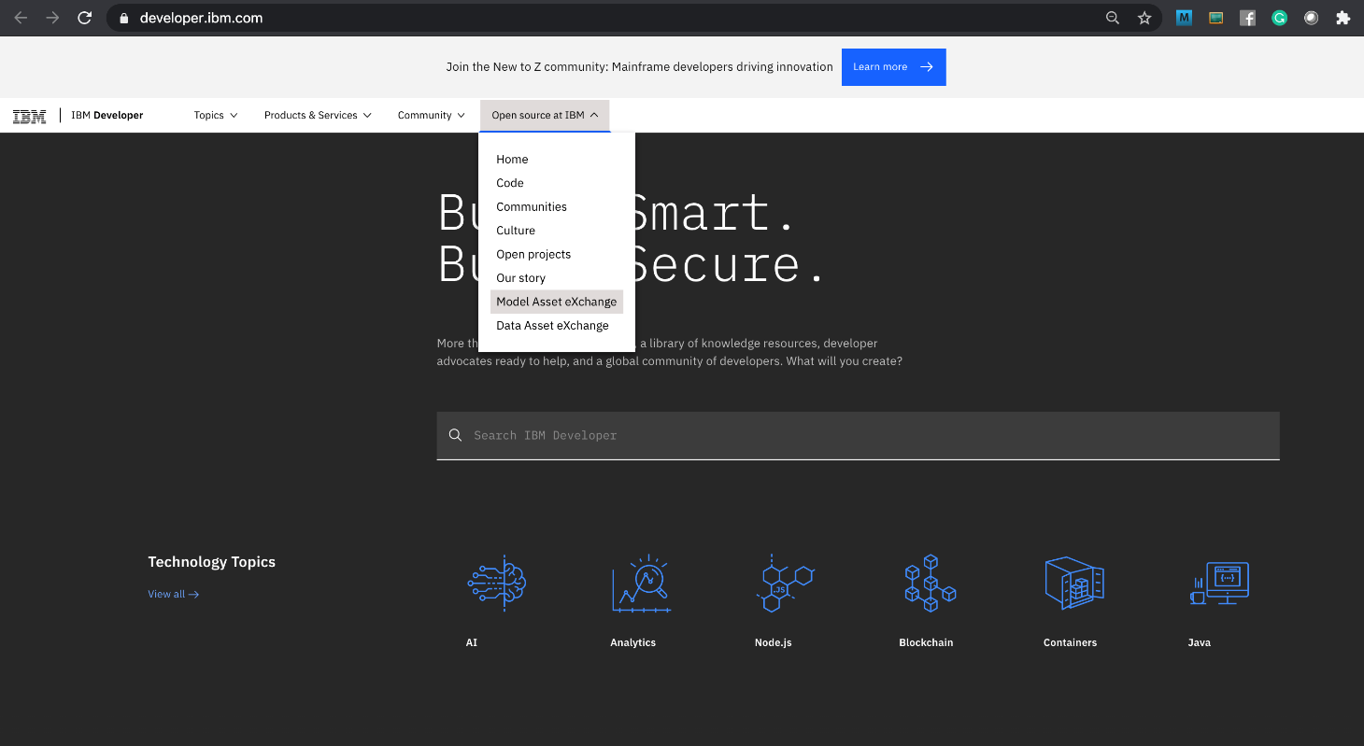

1. The MAX home page is displayed. *In this introductory lab exercise, we are going to focus on a few MAX key features. More detailed information is available in the Learning Path, which covers common deployment and consumption scenarios.*

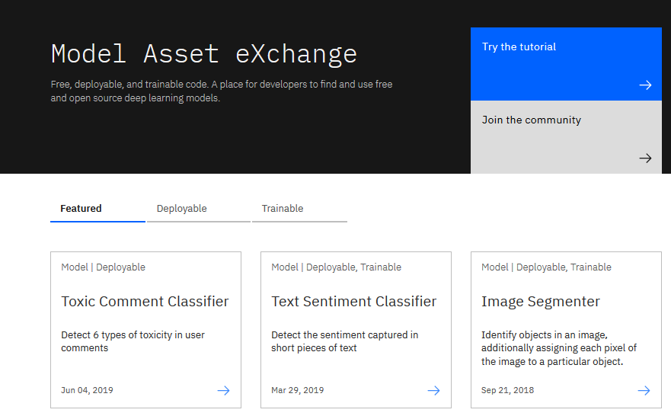

1. Scroll down the page and click on **View all Models**.

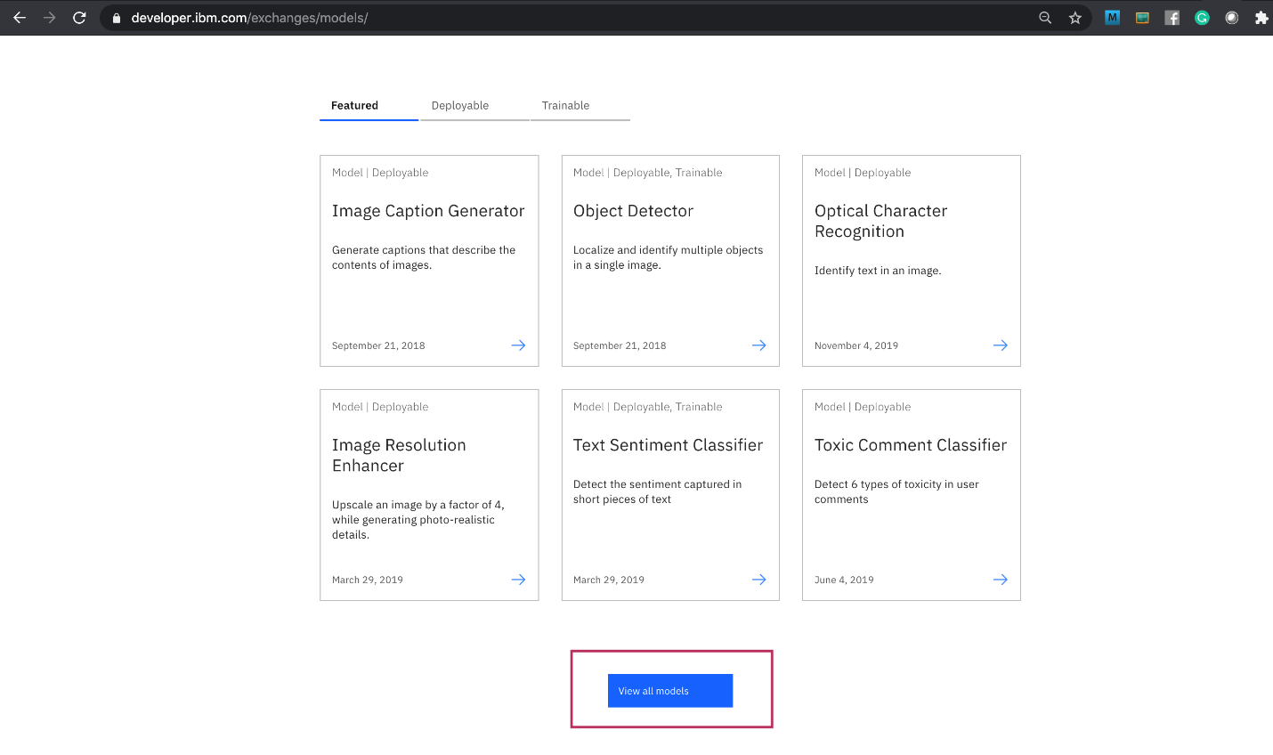

A page with all the models is displayed.

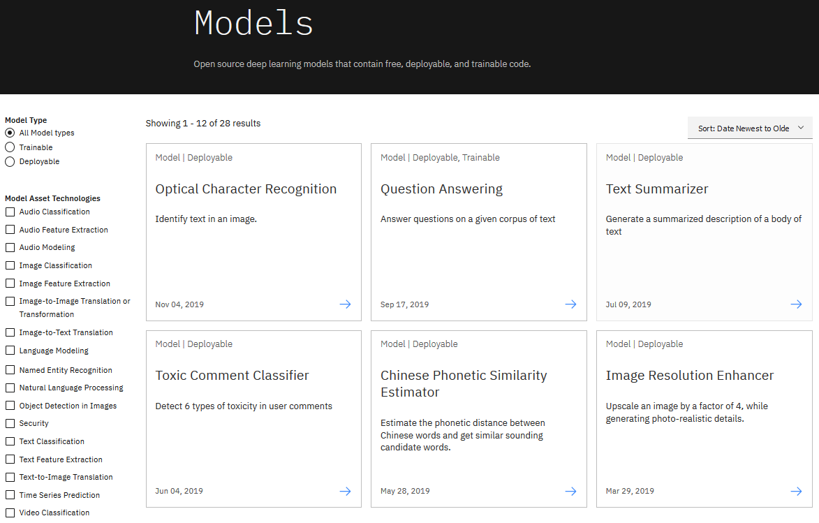

1. Select **Object Detection in Images** from the *Model Asset Technologies* list on the left side.

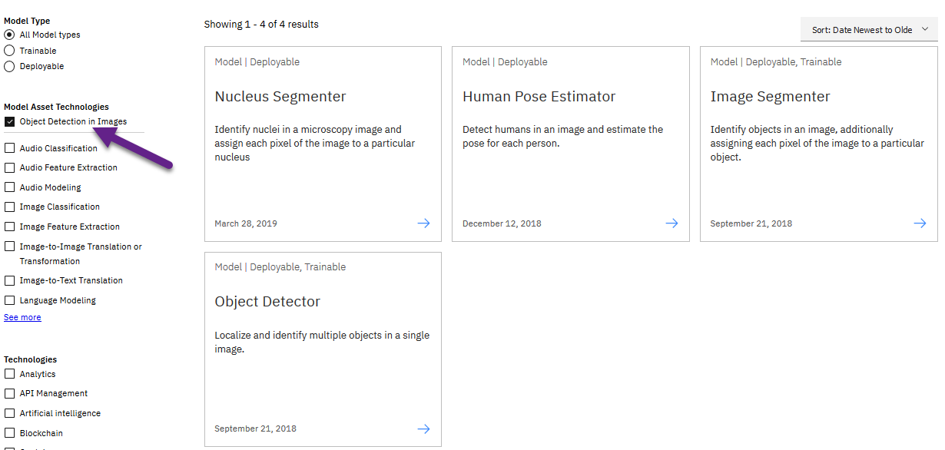

1. Four models should be displayed: Nucleus Segmenter, Human Pose Estimator, Image Segmenter, and Object Detector. Select the **Object Detector model.**

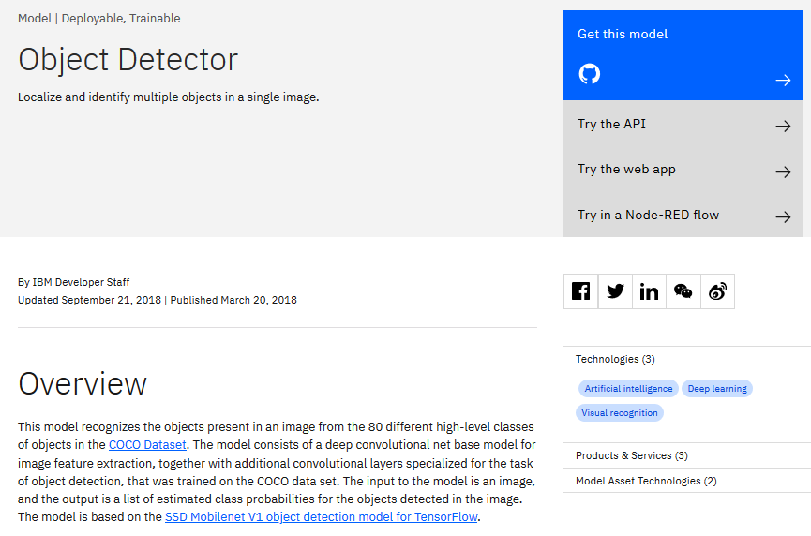

On the model page you can learn about the underlying technology, read up on related research, and explore deployment and consumption options.

1. The model’s source is published on GitHub and can be downloaded and modified if desired. Click “Get this model” to open the repository in a new browser tab (or window) and view the files. You can use this once you are comfortable deploying models.

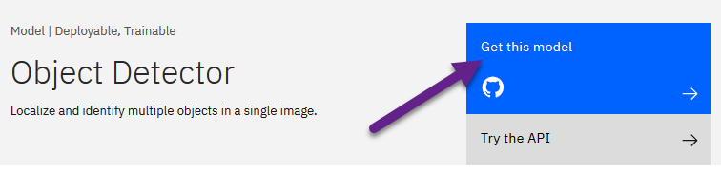

1. Close the GitHub window or tab
2. On the Object Detector page ([https://developer.ibm.com/exchanges/models/all/max-object-detector/](https://developer.ibm.com/exchanges/models/all/max-object-detector?cm_mmc=Email_Newsletter-_-Developer_Ed%2BTech-_-WW_WW-_-SkillsNetwork-Courses-IBMDeveloperSkillsNetwork-DS0105EN-SkillsNetwork-20083975&cm_mmca1=000026UJ&cm_mmca2=10006555&cm_mmca3=M12345678&cvosrc=email.Newsletter.M12345678&cvo_campaign=000026UJ)) on top right, choose **Try the web app**.

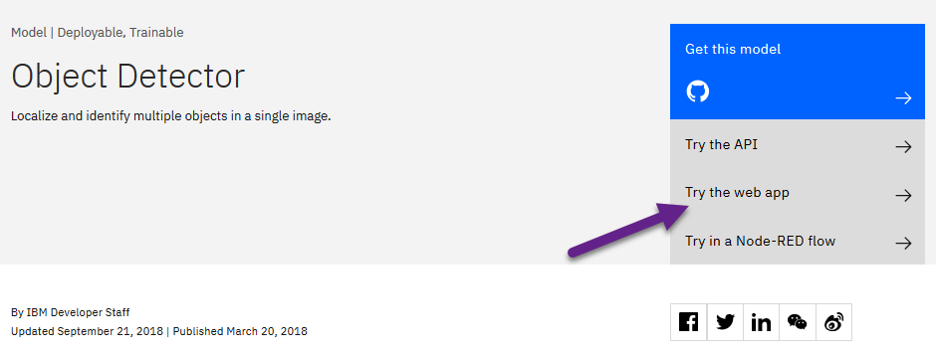

The demo web application uploads an image (or takes a picture using the web cam), sends a request to an Object Detector microservice and visualizes the response by drawing bounding boxes around detected objects and attaching a label.

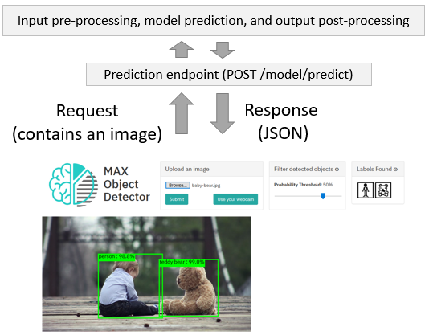

Upload an image (or take a picture using the web camera) and inspect the visualized results.

1. Change the filter conditions (e.g. lower the probability threshold) and observe how they impact the visualized results. Note the web application caches the response and applies the filter on the cached data. This was done for two reasons:

* It eliminates the need to re-process the image using the deep learning microservice (which significantly lowers the application’s response time)
* It illustrates how client-side filtering can be applied to the results if the prediction endpoint doesn’t support filtering by the desired criteria.

If you are interested in learning more about how the application was implemented, take a look at the code pattern: [https://developer.ibm.com/patterns/create-a-web-app-to-interact-with-objects-detected-using-machine-learning/](https://developer.ibm.com/patterns/create-a-web-app-to-interact-with-objects-detected-using-machine-learning?cm_mmc=Email_Newsletter-_-Developer_Ed%2BTech-_-WW_WW-_-SkillsNetwork-Courses-IBMDeveloperSkillsNetwork-DS0105EN-SkillsNetwork-20083975&cm_mmca1=000026UJ&cm_mmca2=10006555&cm_mmca3=M12345678&cvosrc=email.Newsletter.M12345678&cvo_campaign=000026UJ)

This concludes Exercise 1 of this lab, which introduced the Model Asset Exchange.

**Exercise 2:** Explore deep learning datasets

The Data Asset Exchange is a curated collection of open datasets from IBM Research and 3rd parties that you can use to train models.

1. Open [https://developer.ibm.com/](https://developer.ibm.com/?cm_mmc=Email_Newsletter-_-Developer_Ed%2BTech-_-WW_WW-_-SkillsNetwork-Courses-IBMDeveloperSkillsNetwork-DS0105EN-SkillsNetwork-20083975&cm_mmca1=000026UJ&cm_mmca2=10006555&cm_mmca3=M12345678&cvosrc=email.Newsletter.M12345678&cvo_campaign=000026UJ) in your web browser.
2. From the main menu select “Open Source at IBM” > “Data Asset eXchange”. The DAX homepage is displayed.

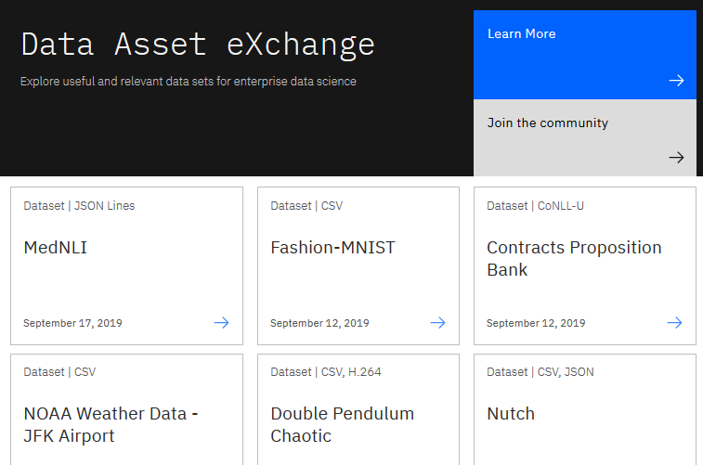

The collection includes datasets from the Debater project ([https://www.research.ibm.com/artificial-intelligence/project-debater/](https://www.research.ibm.com/artificial-intelligence/project-debater?cm_mmc=Email_Newsletter-_-Developer_Ed%2BTech-_-WW_WW-_-SkillsNetwork-Courses-IBMDeveloperSkillsNetwork-DS0105EN-SkillsNetwork-20083975&cm_mmca1=000026UJ&cm_mmca2=10006555&cm_mmca3=M12345678&cvosrc=email.Newsletter.M12345678&cvo_campaign=000026UJ)), datasets that can be used to train models to perform document layout analysis, natural language processing, time series analysis and more.

1. Open the NOAA Weather Data dataset ([https://developer.ibm.com/exchanges/data/all/jfk-weather-data/](https://developer.ibm.com/exchanges/data/all/jfk-weather-data?cm_mmc=Email_Newsletter-_-Developer_Ed%2BTech-_-WW_WW-_-SkillsNetwork-Courses-IBMDeveloperSkillsNetwork-DS0105EN-SkillsNetwork-20083975&cm_mmca1=000026UJ&cm_mmca2=10006555&cm_mmca3=M12345678&cvosrc=email.Newsletter.M12345678&cvo_campaign=000026UJ)), which contains data from a weather station at the John F. Kennedy Airport in New York spanning 8 years. This dataset was used to train the weather forecaster model on MAX (<https://developer.ibm.com/exchanges/models/all/max-weather-forecaster/>).

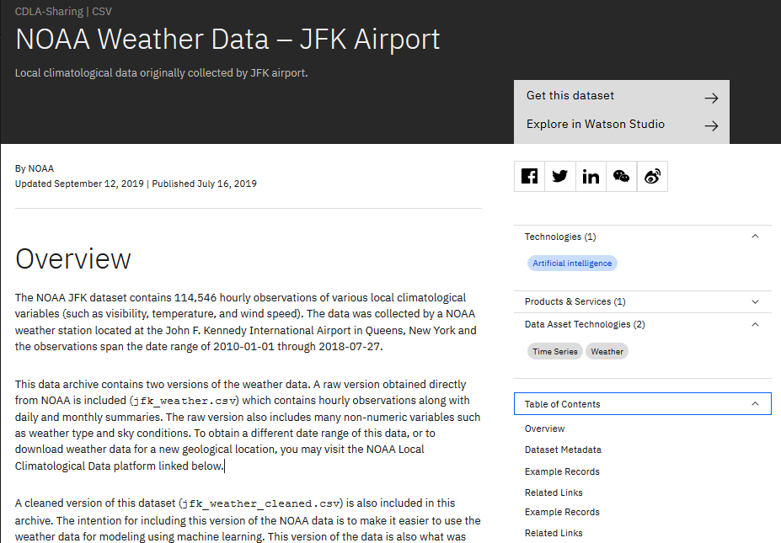

You can download the dataset using the “Get this dataset” link. Datasets are stored as compressed archives, which you can extract using any utility that supports the tar.gz format. If you are not familiar with this file format take a look at this short open source tutorial [https://opensource.com/article/17/7/how-unzip-targz-file](https://opensource.com/article/17/7/how-unzip-targz-file?cm_mmc=Email_Newsletter-_-Developer_Ed%2BTech-_-WW_WW-_-SkillsNetwork-Courses-IBMDeveloperSkillsNetwork-DS0105EN-SkillsNetwork-20083975&cm_mmca1=000026UJ&cm_mmca2=10006555&cm_mmca3=M12345678&cvosrc=email.Newsletter.M12345678&cvo_campaign=000026UJ).

1. Inspect the dataset’s metadata.

This dataset is stored as tabular data and formatted as a comma separated value (CSV) file, which is a very popular basic data exchange format. The dataset was published under the data science friendly CDLA-Sharing license ([https://cdla.io/](https://cdla.io/?cm_mmc=Email_Newsletter-_-Developer_Ed%2BTech-_-WW_WW-_-SkillsNetwork-Courses-IBMDeveloperSkillsNetwork-DS0105EN-SkillsNetwork-20083975&cm_mmca1=000026UJ&cm_mmca2=10006555&cm_mmca3=M12345678&cvosrc=email.Newsletter.M12345678&cvo_campaign=000026UJ)). The dataset contains time-series data and can be used to predict weather trends. 5. Most datasets are complemented by Python notebooks that you can use to explore, pre-process, and analyze the data. You can access the notebook (or notebooks) by clicking the “Explore in Watson Studio” or “Try the notebook” link:

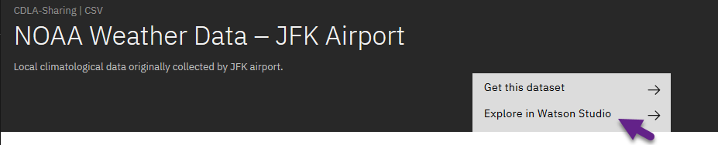

The notebooks are hosted on Watson Studio, IBM’s Data Science platform. Later in this course you’ll learn more about Watson Studio, notebooks and how to run them.

1. [Optional] If you are already familiar with notebooks and Watson Studio feel free to open the link and import the project or notebook. The example below depicts the weather dataset project assets, which include the raw data file and two notebooks.

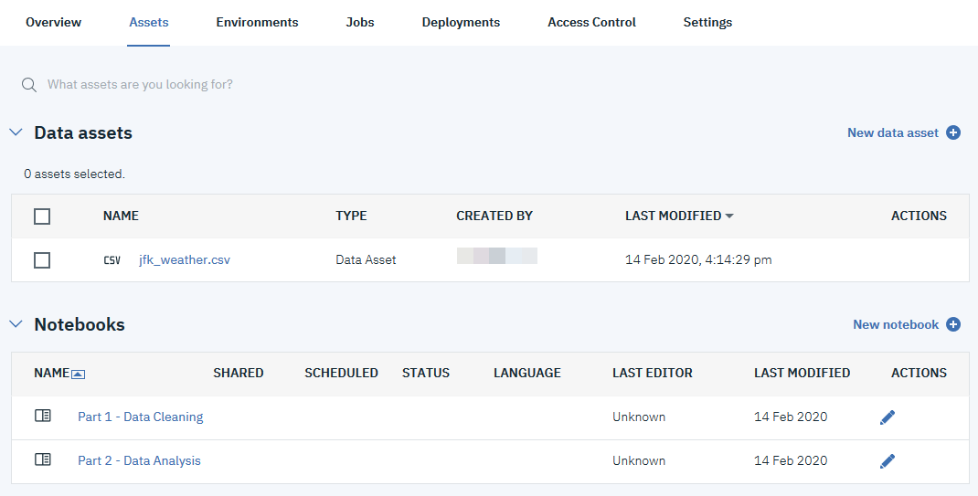

This concludes Exercise 2 of this lab, which introduced the Data Asset Exchange.